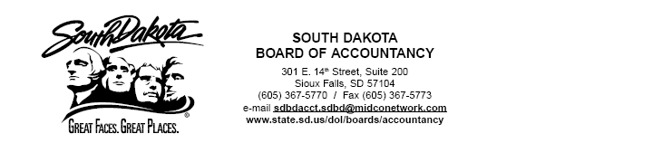

Agenda
South Dakota Board of Accountancy Meeting
Conference Call
June 4, 2007
A=Action
D=Discussion
I=Information Page #’s

A-Approval of Minutes of Meeting April 30, 2007…..………………………………………. 1-4

A-Approval of Certificates and Firm Permits………………………………………………….. 5-6

A-Financial Statements through April 30, 2007…….….………………………………………. 7-18

PCAOB

I-Board to Vote on New Standard for Audits of Internal Control………………………………. 19

I-PCAOB Concludes First International Auditor Regulatory Institute…………………………. 20

NASBA Issues

I-Highlights of the Board of Directors Meeting April 27, 2007………………………………… 21-22

I-Minutes of the Board of Directors Meeting January 19, 2007…………………………………. 23-35

I-Regional Director’s Focus Questions Executive Summary April 2007………………………… 36

I-Regional Directors Report April 2007…………………………………………………………... 37-47

I-Recommendations for Director-at-Large………………………………………………………... 48-58

I-Recommendations for Regional Directors………………………………………………………. 59-62

PEER REVIEW

Equivalent Reviews for Board Approval………………………………………………………… Spt. Pkt.

Follow Up Reviews………………………………………………………………………………. Spt. Pkt.

Complaint Compliance…………………………………………………………………………… Spt. Pkt.

FUTURE MEETING DATES
July 10, 2007- 10:00 Conference Call
August 13, 2007- 8:30 Eide Bailly Conference Room, Sioux Falls

