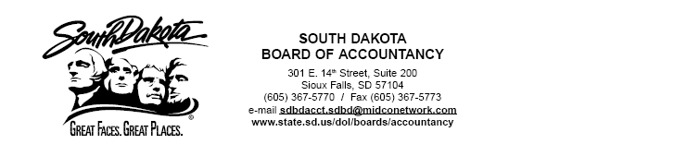

Agenda
South Dakota Board of Accountancy Meeting
Department of Legislative Audit, Conference Room
Pierre, SD
April 30, 2007
A=Action
D=Discussion
I=Information Page #’s

A-Approval of Minutes of Meeting March 26, 2007…..………………………………………. 1-4

A-Approval of Certificates and Firm Permits………………………………………………….. 5-6

A-Financial Statements through March 31, 2007.……..………………………………………. 7-18

A-Report to Board on Grades………………………………………………………………….. 19-21

D-Report to Board on Executive Director’s Meeting………………………………………….. 22

I-Report to Board on CPE Audits……………………………………………………………… 23-24

D-Information on Lapsed Licenses by Sherri Wald……………………………………………. Oratory

D-Report on Audit for two years ended June 30, 2006 by Don Finstad……………………….. 25-46

AICPA

I-Announcement of new Director of Examinations Strategy…………………………………... 47

I-Report on status of 2008 Practice Analysis…………………………………………………... 48-50

D-Exposure Draft Executive Summary on Peer Review Program……………………………... 51-76

PCAOB

I-Deputy Chief Auditor, Laura Phillips, to leave PCAOB……………………………………… 77-78

I-Report on the Second-Year Implementation of Auditing Standard No. 2…………………….. 79-91

I-Chairman, Mark Olson’s Testimony Concerning the Sarbanes Oxley Act of 2002 and Its
Impact on Small Businesses…………………………………………………………... 92-108

NASBA Issues

D-Highlights of Recent Regulatory Developments 2006-2007………………………………….. 109-112

I-Nomination of Theodore W. Long, Jr. for NASBA Director at Large………………………… 113

I-Nomination of Gaylen Hansen, CPA, for NASBA Director at Large &
Support Letter from Idaho Board of Accountancy……………………………………… 114-116
Agenda
Page 2

I-New Hampshire Letter of Support in regards to West Virginia’s concerns on 150 Hour Rule… 117-118

PEER REVIEW

Equivalent Reviews for Board Approval………………………………………………………… Spt. Pkt.

Follow Up Reviews………………………………………………………………………………. Spt. Pkt.

Complaint Compliance…………………………………………………………………………… Spt. Pkt.

FUTURE MEETING DATES
June 4, 2007 by Conference Call at 10:00 (CT)
July 10, 2007 by Conference Call at 10:00 (CT)
August 13, 2007 in Sioux Falls, SD 8:30 (CT)

